Table of Contents
The reason DC/DC alternative was chosen [Over LDO] 2
Input voltage 2
New project on Altium Designer 4
Define pcb layout 6
From metric to imperial 7

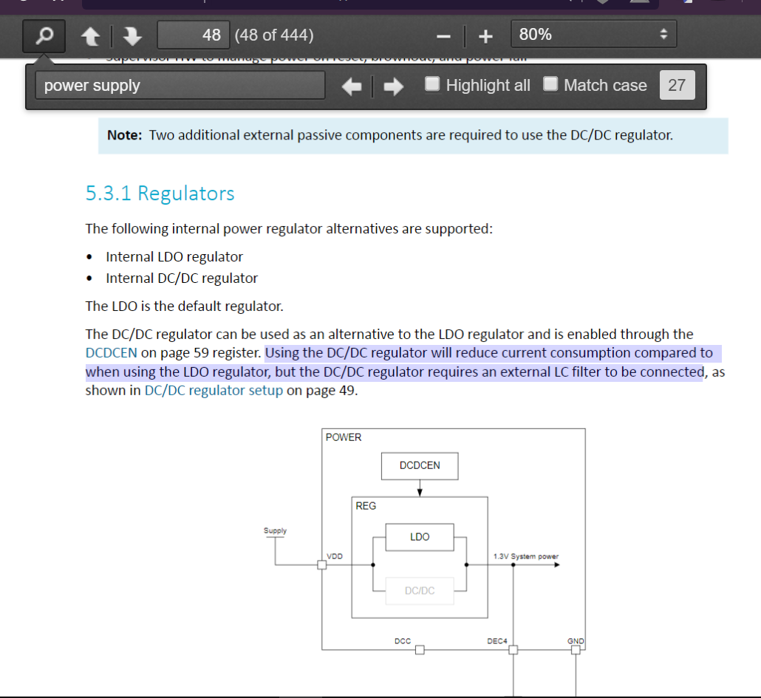
The reason DC/DC alternative was chosen [Over LDO]

Input voltage
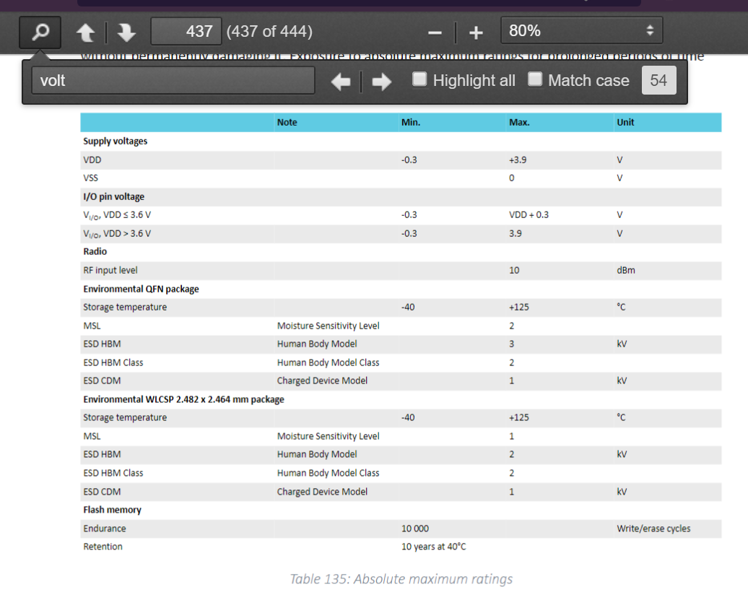
Recommended is 3.0 V. Max is 3.9V.
Normally, values from 1.7 to 36V can be accepted.
[page 2 of datasheet]

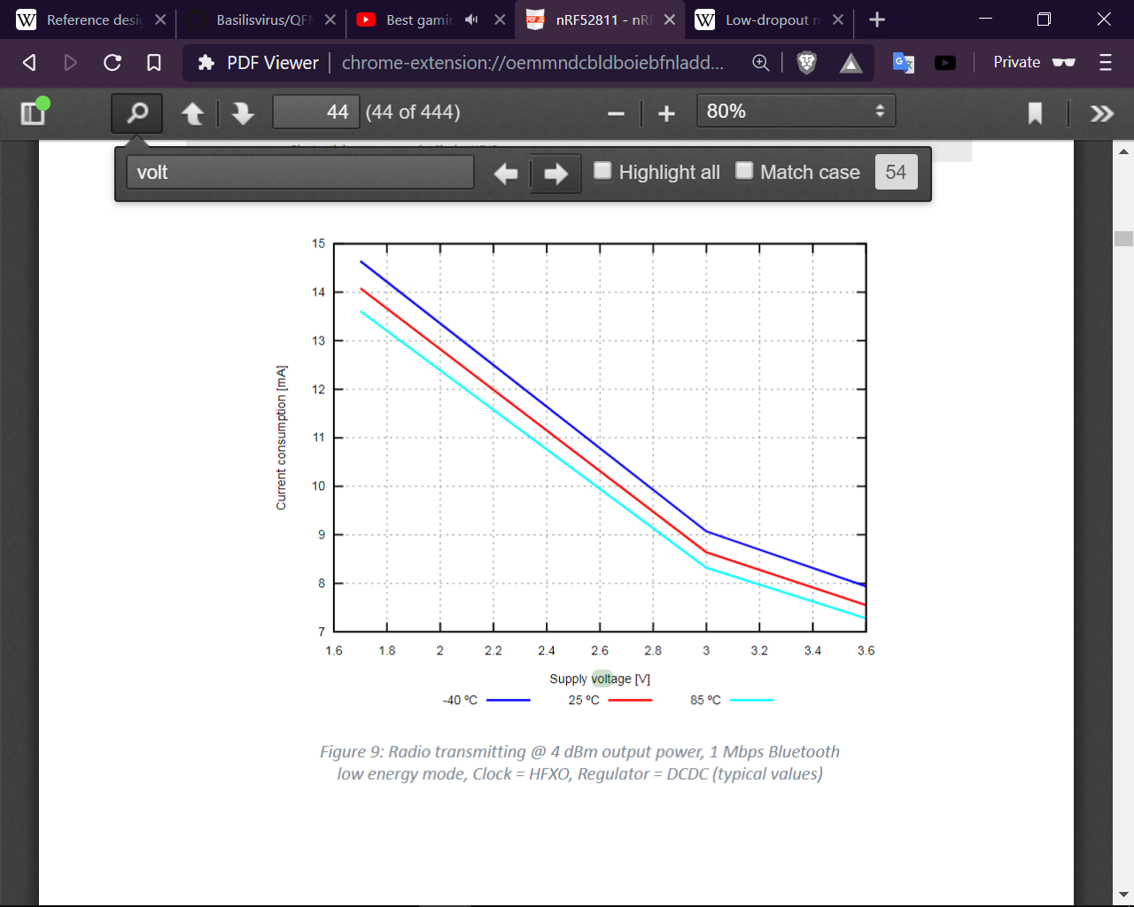

New project on Altium Designer
The process of using and learning the basics of Altium for the first time. [Learned from a youtube video tutorial]
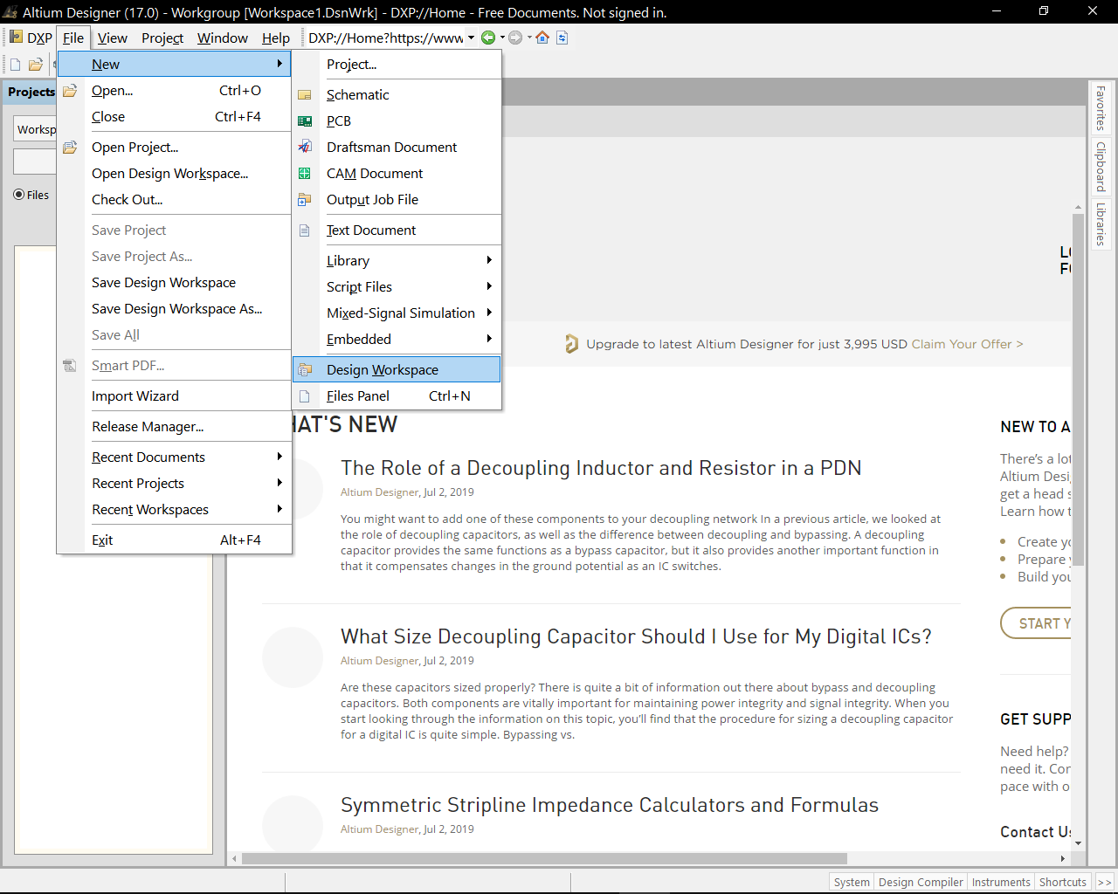
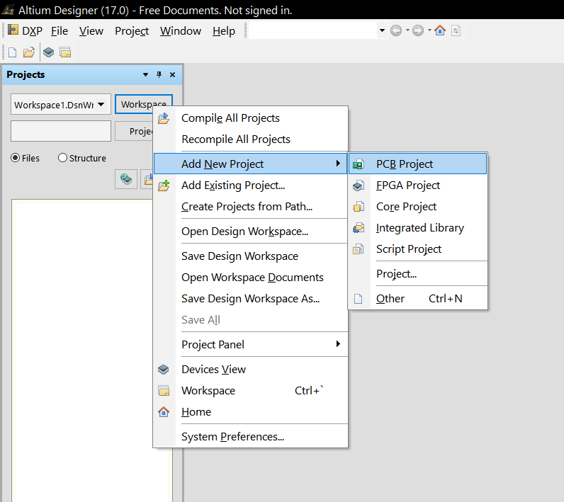

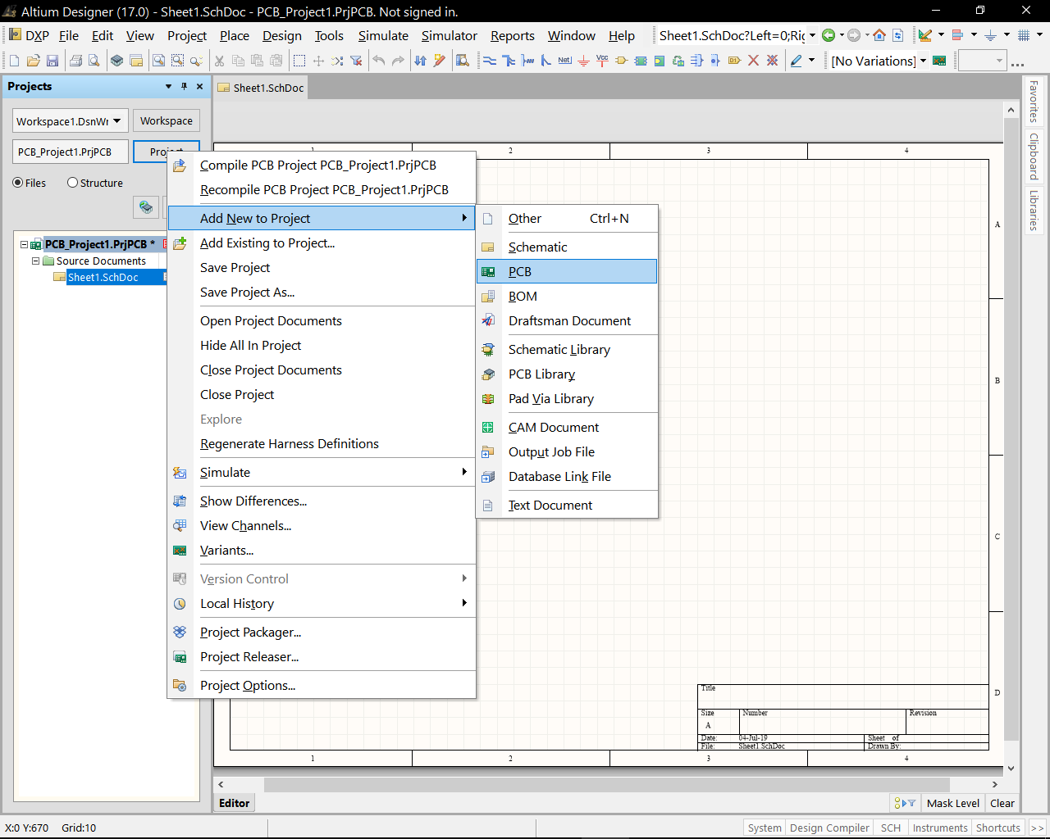

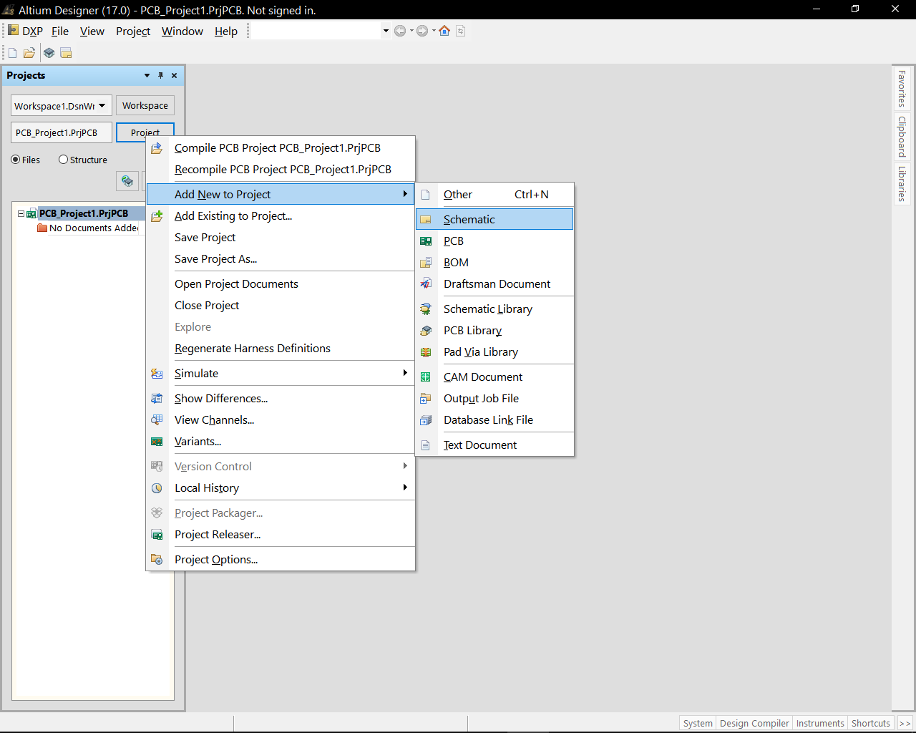

How pcb looks like:

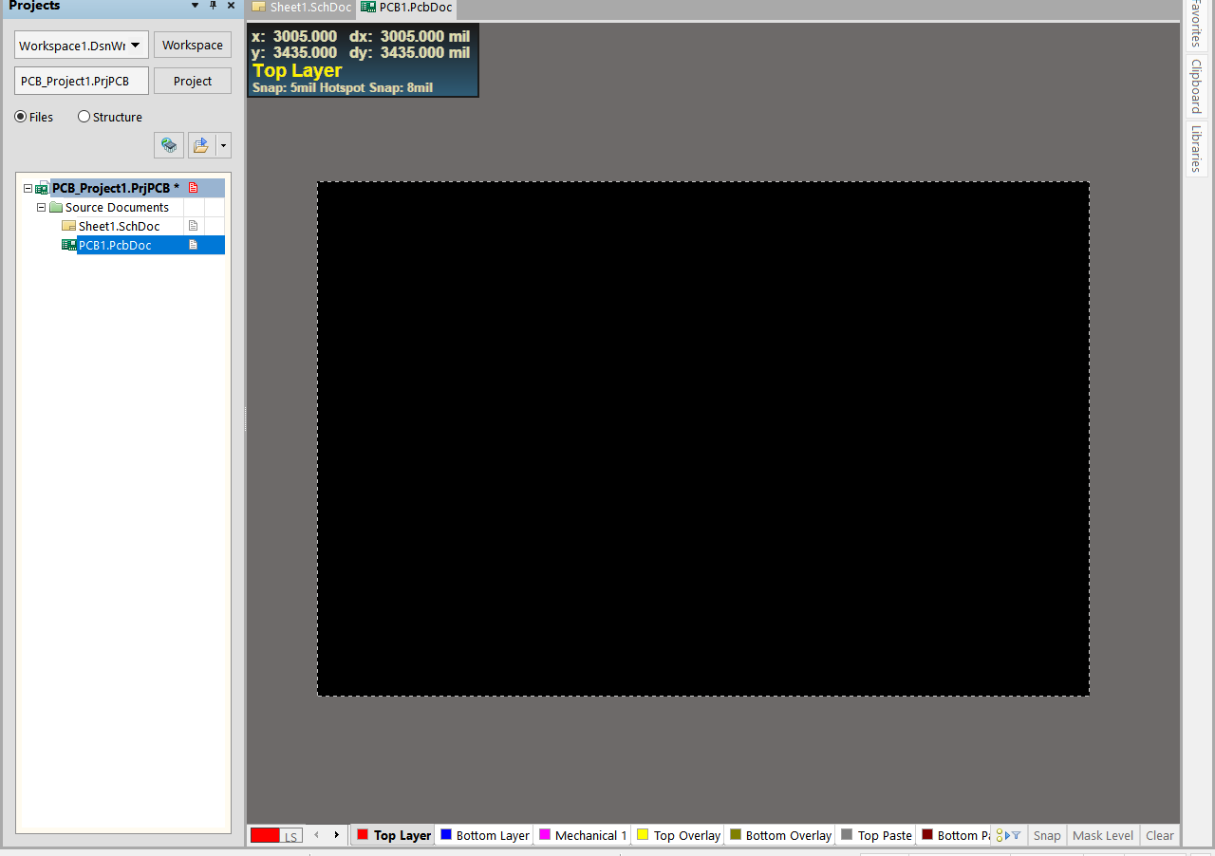

How schematic looks like:
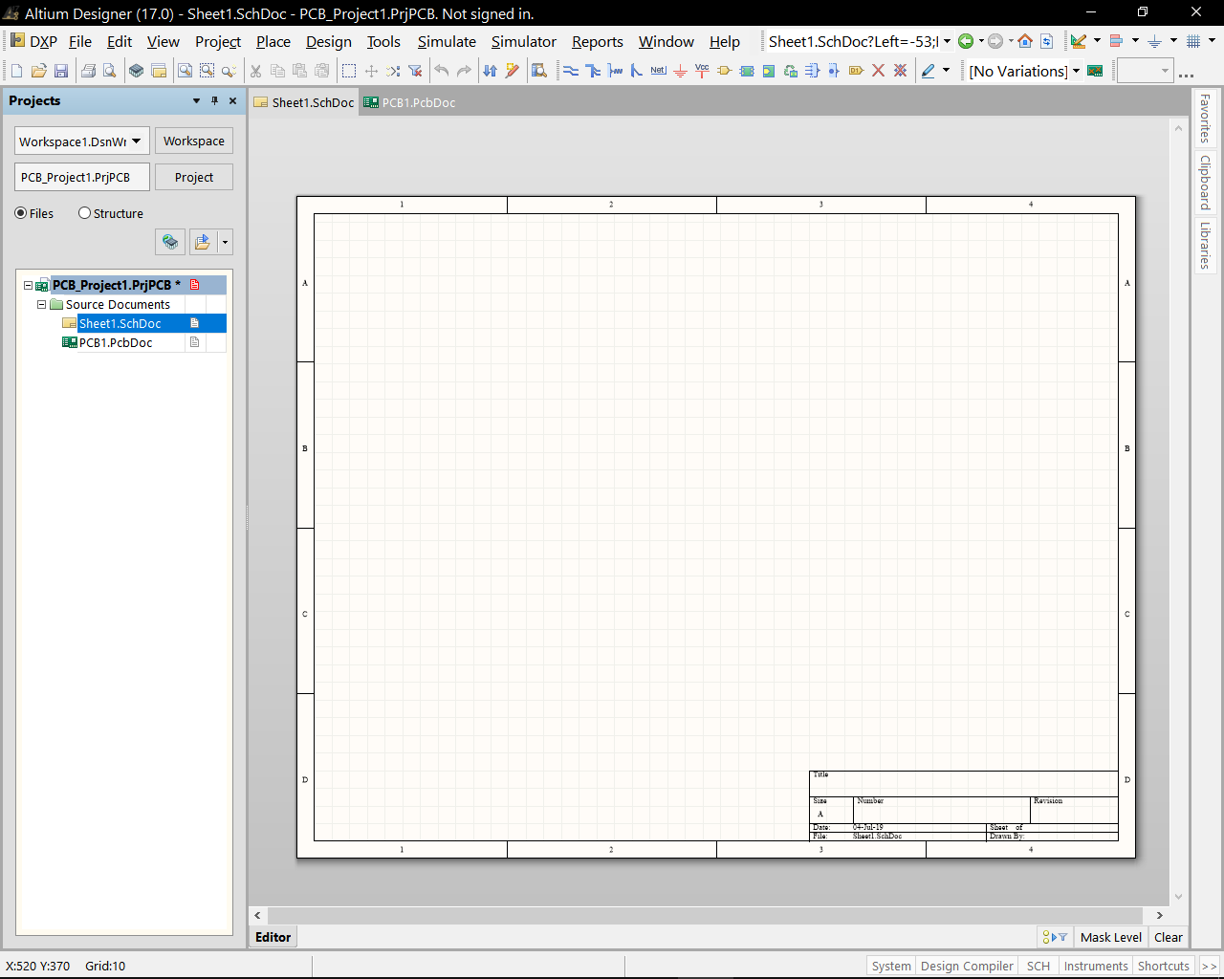

Define pcb layout

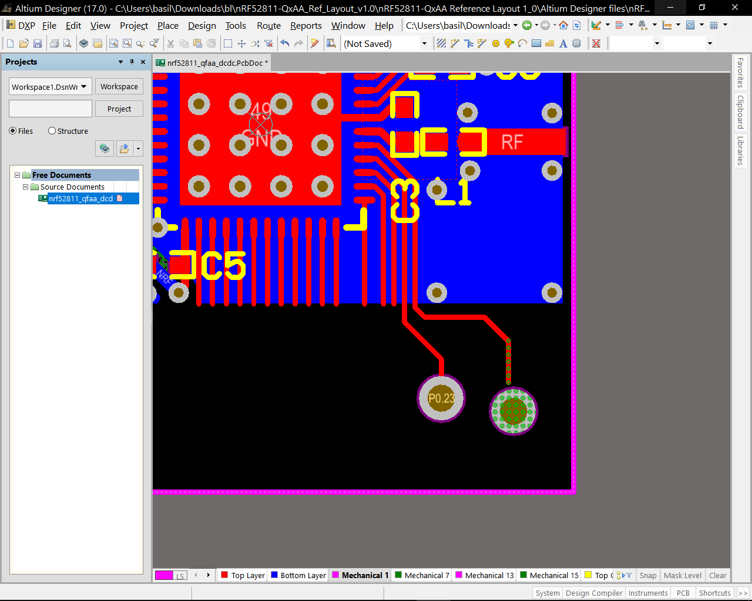
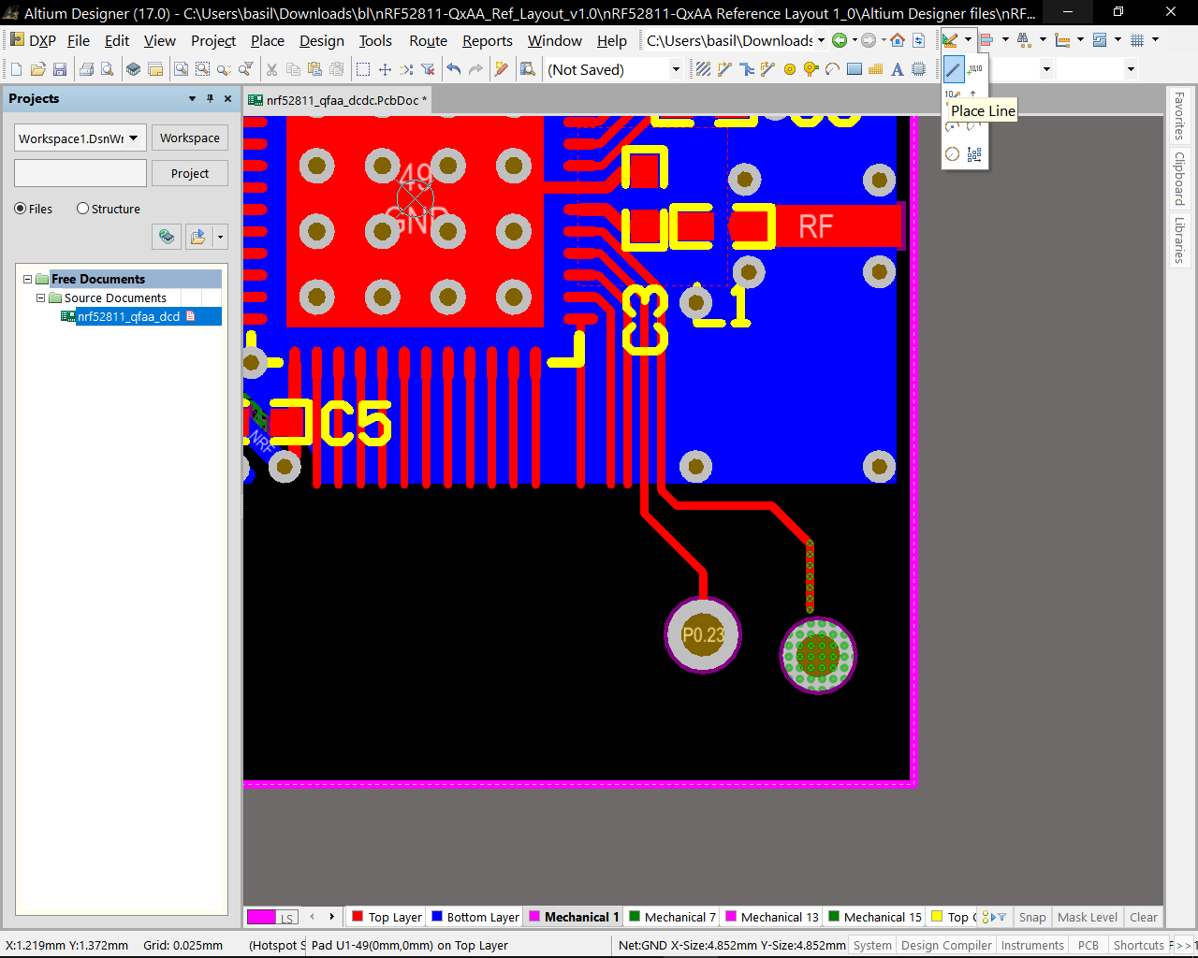

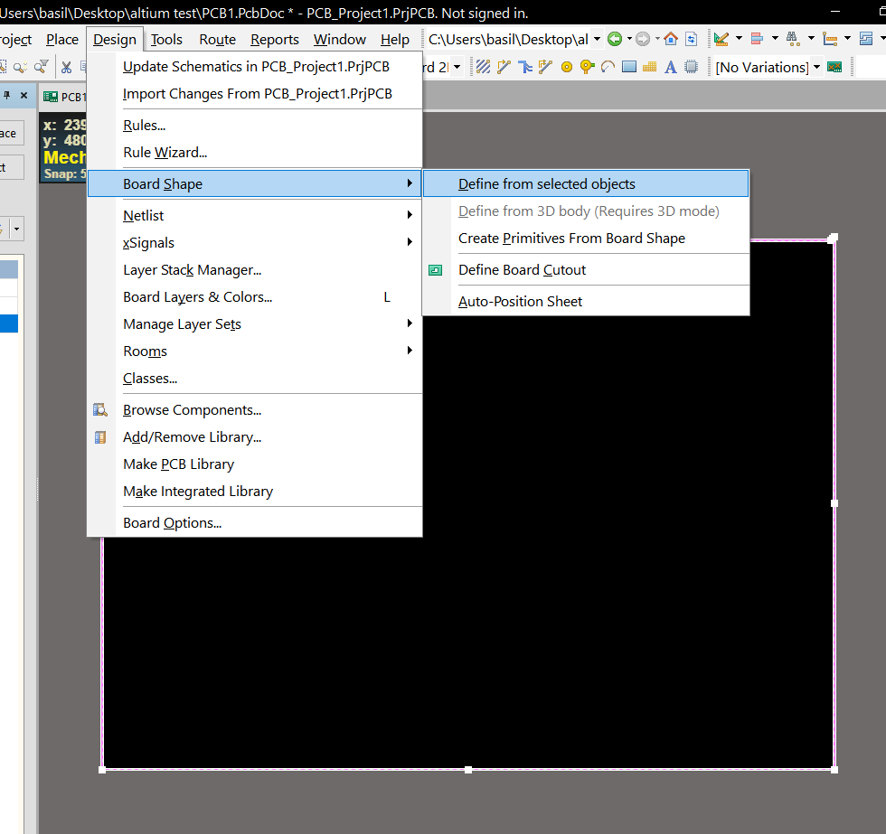

From metric to imperial
